Meeting Notes

***Meeting Agenda*** – Second Testing – combining the work conducted by the electrical and software team to do a complete test and obtain an EL image

***Meeting Attendance:***

Andrew Leong (u6283651)

Yixin Lu (u7411857)

The other team member’s presence was not necessary since the GUI is being developed by Yixin within the software team.

|  |  |
| --- | --- |
| ***Meeting Notes:*** | ***Meeting Duration – 60 minutes*** |

The meeting agenda was to build the dashboard for GUI and how it would appear on the Raspberry Pi. Andrew L attended this meeting to provide inputs based on the client documents. Together a potential dashboard was brainstormed. The images below show the potential dashboard development.

***Meeting Outcomes:***

1. Discuss the GUI dashboard

***Current Deliverables[1]:***

Develop the dashboard and execute it to work in sync with the algorithm

***Appendix***

Image 1

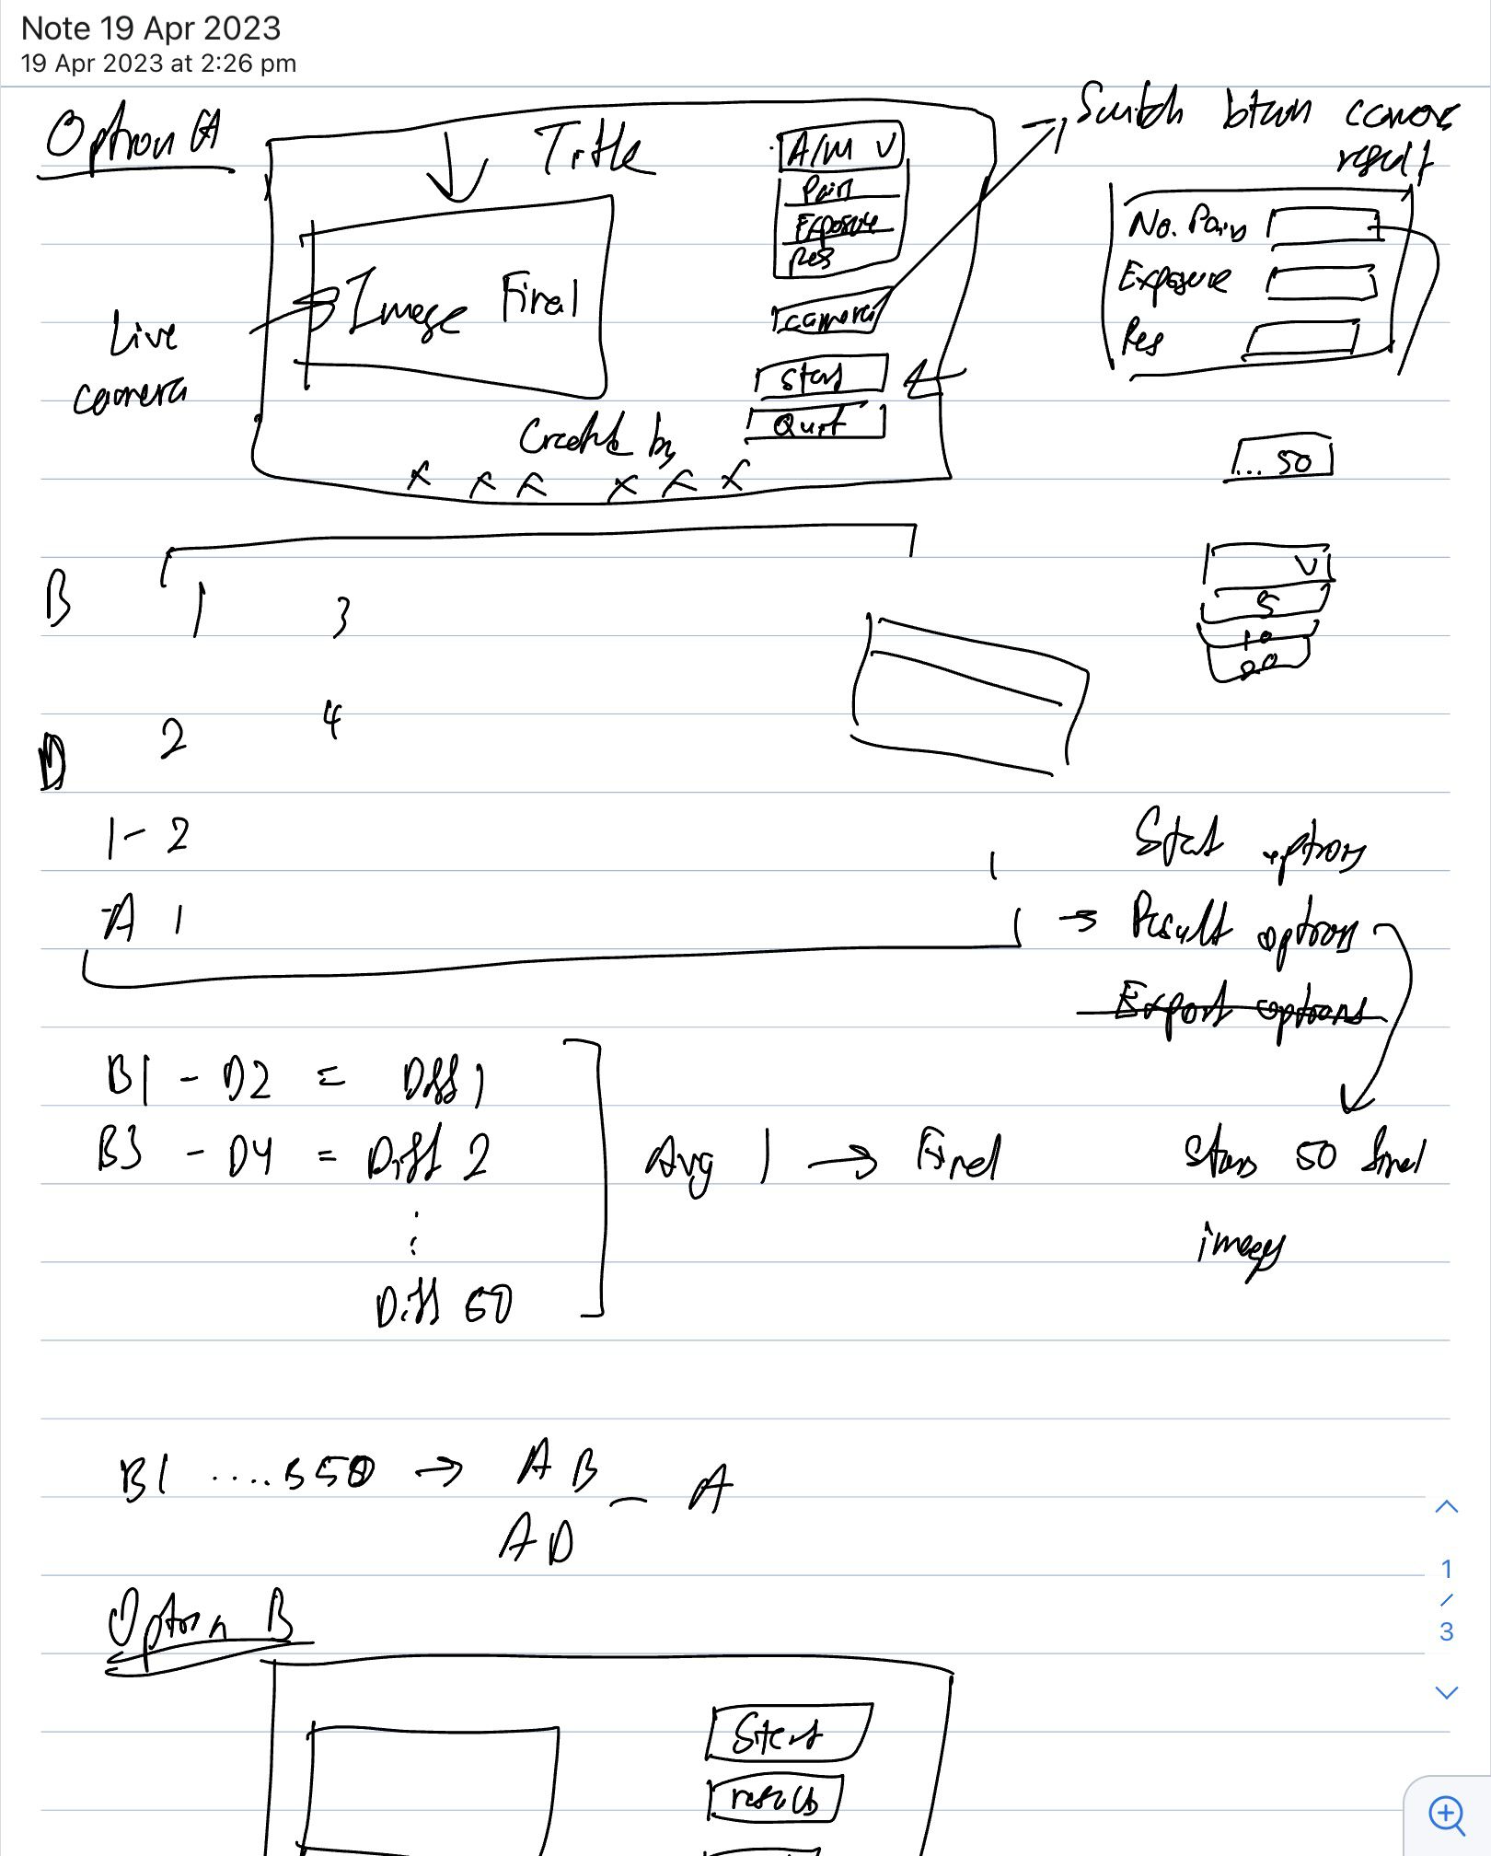

Image 2

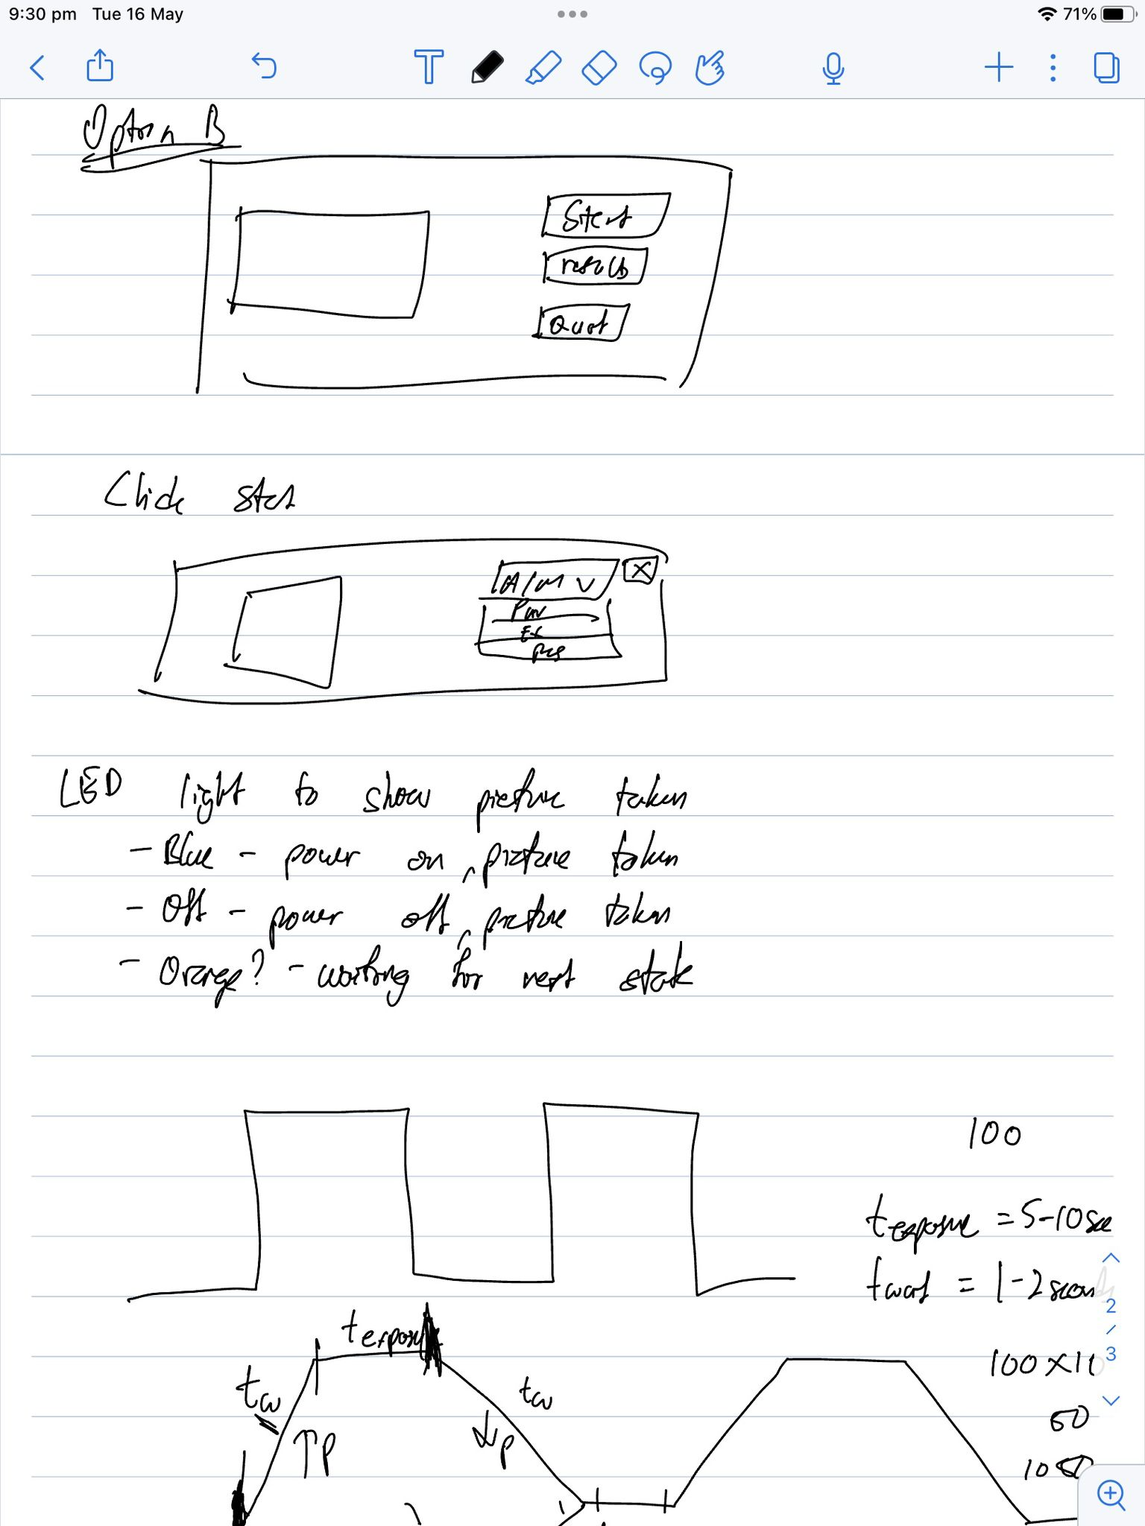

1. Current Deliverables: Refers to immediate tasks that need to be performed prior to the next meeting.